Implementation of a centralized scheduling algorithm for real-time industrial IEEE 802.15.4e TSCH Networks
Ngoc-Huy NGUYEN¹ and Myung-Kyun KIM¹
¹ University of Ulsan, 44610 Daehak-ro 93, Nam-gu Ulsan, South Korea mkkim@ulsan.ac.kr
Abstract. Wireless Sensor Networks (WSNs) are becoming more popular to support a wide range of applications in the era of the Internet of Things (IoT). IEEE802.15.4e with a MAC protocol named Time-Slotted Channel Hopping (TSCH) is a technique to enable high-reliable and ultra-low-power wireless multi-hop networks. In this paper, we describe the implementation of a centralized link scheduling for IEEE 802.15.4e TSCH, known as Path Conflict free Least Laxity First (PC-LLF) Algorithm. PC-LLF prioritizes the assignment of the dedicated cell for each transmission. To install the schedules, we implemented a method to send the schedule information packets for each node through the tree path called Unicast Installing Schedule Algorithm. The aim to reduce packets size to carry more schedule information in each packet, avoid packet loss, and reduce the time to install schedule. We compared our method with the broadcast of the same packet by using standards such as CoAP and CoMI or using a custom protocol such as OCARI. We implement in Contiki-NG OS and the devices are Zolertia RE-Mote B. The implementation to make a real-time IoT network running a centralized scheduling algorithm of TSCH which can be applied in the industrial networks.
Keywords: Low-Power Wireless Mesh Networks, IEEE802.15.4e TSCH, PC-LLF, CoAP, CoMI, OCARI, Contiki-NG OS.
- Introduction
The use of Wireless Sensor Networks (WSNs) in the industrial area is growing such as monitoring applications, radiation checks, leakage detection, distributed, and process control [1]. Industrial low-power wireless mesh network applications have strong requirements in terms of latency, energy efficiency, and reliability. The end-to-end delay is constrained by upper bounds which varies according to the field of application [2]. To overcome these challenges, the IEEE802.15.4e amendment introduces the Time Slotted Channel Hopping (TSCH) mode [3]. With the time-slotted and channel hopping features, TSCH reduces latency and ensures high resistance against interferences as well as multipath fading. Although the IEEE802.15.4e standard defines the method to execute the communication schedule, it does not clarify how the schedule is built, maintained, updated as well as the design of the object in charge of performing tasks.
All communication is constructed from a communication schedule, which indicates to each node what to do in each slot: transmit, listen, or sleep. This schedule can be served for any purpose such as collision-free communication, yielding predictable behavior, ultra-high reliability, and extended battery lifetime.
Scheduling schemes could be classified by the entities that create and manage the schedules: centralized, distributed, and autonomous schedule. Centralized scheduling, a central entity performs the creation and management of the schedule base on network topology information and link status from the nodes to create schedules. Distributed scheduling, each node in the network performs the creation and management of the schedules by negotiations with neighbor nodes. Autonomous scheduling determines the schedule according to the pre-established rules without information collections or negotiations among nodes for schedule creation and management, thereby reducing the collection overhead.
Building the schedule consists of assigning a source node, a destination node, and a channel to cells in the schedule. Installing the schedule into the network means indicating to each node the list of cells it is involved in. In this paper, we will base on a realistic centralized scheduling algorithm known as Path Conflict free Least Laxity First (PC-LLF) [4]. Path Conflict free Least Laxity First (PC-LLF) algorithm dynamically prioritizes the packets based on the laxity time to the end-to-end deadlines and the average number of collisions that messages might deal with along their designated paths to the coordinator.
With the purpose to give a contribution to the study of the implementation of centralized scheduling for the real-time industrial TSCH networks, we implemented PC-LLF scheduling in the Zolertia RE-Mote B kit using Contiki-NG OS. As the coordinator node makes the schedules to be used in a given network, the important key during the implementation of centralized scheduling is the reception by all nodes in the network of the schedule table information packet. To carry more schedule information in each packet, avoid packet loss, and reduce the time to install the schedule. We designed a method to send it in a unicast manner by assigning to each node its timeslot to send the packets, which eliminates competition between nodes, reduces a collision, and decreases the loss.
The remainder of this paper is organized as follows. In Section 2, we discuss some background information and related works. The PC-LLF scheduling algorithm will be described in Section 3. In Section 4 we present the implementation process. In Section 5, we will show the evaluation of our implementation and the conclusion will be given in Section 6.
- Background
  - IEEE 802.15.4e TSCH
In a TSCH network, nodes are synchronized by using Absolute Slot Number (ASN). This is the total number of timeslots that have elapsed from the start of the network or a randomly determined start time by the coordinator. It is known as the global synchronize time of the TSCH network. Time in TSCH is divided into timeslots. The duration of a slot is implementation-specific, even though a 10ms length is suggested in the standard. One timeslot is long enough for the transmission of a data frame and its acknowledgment. In TSCH, a maximum of 16 channels can be used for communication. Multiple nodes can communicate at the same time slots using different channel offset. The communication between 2 nodes in TSCH occurs in the cell which is a pair of the timeslot and channel offset in that timeslot. A cell can be shared or dedicated, i.e. contention-based with CSMA back-off or contention-free respectively. In this paper, the PC-LLLF centralized scheduling algorithm allows only the use of dedicated cells.
  - Contiki-NG OS
Contiki-NG is an open-source, cross-platform operating system for Next-Generation IoT devices. It focuses on dependable (secure and reliable) low-power communication and standard protocols, such as IPv6/6LoWPAN [5], 6TiSCH [6], RPL [7], and CoAP. Contiki-NG OS includes an event-driven kernel used to load and unload process at run time. The system runs on a variety of platforms based on energy-efficient architectures such as the ARM Cortex-M3/M4 and the Texas Instruments MSP430. The code footprint is on the order of a 100 kB, and the memory usage can be configured to be as low as 10 kB. In our implementation, we use Zolertia RE-Mote B which is compatible with Contiki-NG OS. The Zolertia is based on TI's CC2538 system on chip (SoC), featuring an ARM Cortex-M3 with 512KB flash, 32Kb RAM, double RF interface.
- PC-LLF: Path Conflict Aware Least Laxity First Algorithm
The PC-LLF algorithm [4] is a centralized algorithm designed to make a schedule over IEEE 802.15.4e TSCH to reduce the latency of the data packets by finding the possible schedules for all transmissions of each flow along their designated path. The transmission in TSCH occurs at a certain time slot t and channel ch, which compose a cell (t, ch). Each cell(t, ch) assigned the type of work is Transmit (Tx) or Receive (Rx). PC-LLF algorithm conforms to some constraints of that technology. Firstly, the network forms a tree topology network (Fig.1) as a Directed Acyclic Graph (DAG) G = (N, L) where N = {${ N}_{1},N_{2}$, …,${ N}_{n}$} represents all the nodes in the TSCH networks and L($N_{p}, N_{q}$) are communication links. ${ N}_{1}N_{2}$represents a link L($N_{1}, N_{2}$) where ${ N}_{1}$is the transmitter node and ${ N}_{2}$ is the receiver node. The interferences links cannot be scheduled on the same cell and the duplex conflicting links cannot share the same time slots. Two links interfere with each other if the receiver or sender of one link can overhear transmissions by the sender of the other link and the duplex conflicting links are all the links that have the same receiver or sender nodes. It means that a node can not receive or transmit multiple times or at the same time. For example in the Fig.1, duplex conflicting links of the link${ N}_{4}N_{2}$ is denoted by CNF($N_{4}N_{2}$) = {${ N}_{3}N_{2}, { N}_{5}N_{4}, N_{11}N_{4}$}.

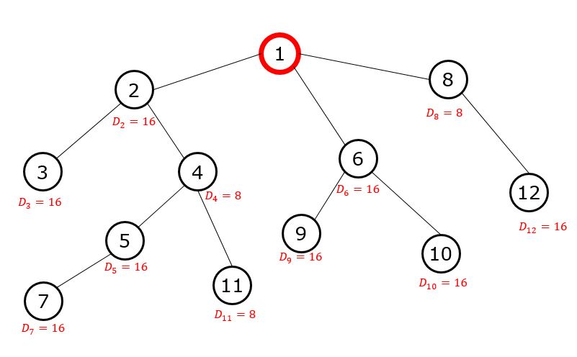
Fig. 1. An example of network G = (N, L), N= {${ N}_{1}$, $N_{2}$, …, $N_{12}$} with D is the Data Period assigned to each transmission from its source. $N_{1}$ is the coordinator node.
All transmissions are upward from the node to the coordinator and follow the data period. The data period is the power of two. PC-LLF uses the Least Common Multiple (LCM) of all the data periods in the network to calculate the slot frame size. For Fig.1, the LCM of the network is 16, thus the slot frame length is 16. This slot frame will be repeated during the lifetime of the network. To determine the priority used by PC-LLF to make a feasible schedule, PC-LLF considered time window denoted ${TW}_{(x, y)}$for each transmission which is the time phase from the earliest time slot (x) and the latest time slot (y) that the transmission can occur. The earliest time slot is the actual time slot and thus it is recomputed at each timeslot. The latest time slot depends on the deadline value. The second parameter is the average delay due to collisions of each remaining transmissions that may deal with at the time slot t. The considered collisions are duplex conflicting collisions that happen due to a transmission existing in a conflicting link with a time window TW that overlaps with the time window of the considered transmission.
Let denote the number of conflict transmissions with a certain transmission $T_{i}$ as $NCF(T_{i})$. To get the average latency of a packet due to the collisions through the remaining path at a certain time slot.
The remaining path is considered to be composed of the actual transmission and the future transmission of the packet to reach the root nodes. The average latency due to duplex conflicting transmission at a certain time slot t denoted${DCF}_{avg}\left(T_{i}, t\right)$ and its value change at each time slot because the amount of duplex conflicting transmissions change due to some transmissions may be scheduled previously can be conflicted with the current transmission. Denote k is the number of hops counts away for a transmission to reach the root node. The average latency is given by the sum of all conflicting links divided by the number of hop count as in the equation below:
${DCF}_{avg}\left(T_{i}, t\right)= \sum{NCF(T_{i})/k}$ (1)
From the equation (1), the priority of a transmission at a certain time slot t is computed by the difference between the time window of the packet’s transmission and its average latency as described in the equation below:
$PR\left(T_{i}, t\right)={TW}_{(x, y)}- {DCF}_{avg}(T_{i}, t)$ (2)
The lowest value corresponds to the highest priority. Based on the computed priorities for all transmissions follow equation (2), the PC-LLF algorithm assigns the time slot and channel to the transmission with the highest priority. When some transmissions have the same priority, the transmission with the smallest length of time window will be assigned. Moreover, if we use more than one channel, among the transmissions which are not in duplex conflict with the previously assigned transmission, the transmission with the highest priority is assigned to a different channel at the same time slot.
- Implementation
To give a big picture of the implementation process, we divided it into five parts. Firstly is the initialization step, all the sensors node are in scanning mode, only the coordinator broadcast Enhanced Beacon(EB) to form the network. After that is the tree construction step where nodes make a network topology using the RPL routing protocol which built-in Contiki-NG OS. The third step is executed by the root node to make the schedule table base on the PC-LLF algorithm. After making the schedule root node send the schedule information packets to all the nodes through the path. Lastly, all nodes will start data transmission following the PC-LLF assignment (Fig.2).
Fig. 2. Implementation Process.
  - Initialization
At the initial step, we use orchestra sender-based to formation the network. All the nodes use the same channel and assigned transmit(Tx) time slot equal to its node id. Firstly, all sensors node does not join the network, they are in scanning mode. The coordinator will broadcast the Enhanced Beacon(EB) packet which contains the synchronize information of the TSCH network. After the nodes join the network, it will synchronize with the coordinator, then the joined node will become a new broadcaster of the network.
  - Tree construction
Contiki-NG OS includes the RPL Classic and RPL Lite for routing [7]. RPL Lite removes support for storing mode in favor of non-storing mode and removes the complexity of handling multiple instances and DODAGs. RPL Lite typically exhibits better performance and has a considerably smaller ROM footprint. On the flip side of these optimizations, it has a lower interoperability level with other implementations, which may use storing mode for instance. We chose to use RPL Lite as it allows the root node to collect all network information from each node in the network through the exchanged packets. We assume a fixed number of nodes in the network and are known by the root node in the beginning. After building the tree, all the nodes send all the information that contains node id, parent id, and data period to start running the PC-LLF Algorithm.
  - Make PC-LLF Schedule
With the information collected by the root node during the tree construction period, the root node executes the PC-LLF Algorithm to make a schedule for all the nodes in the network. In case PC-LLF can not make a schedule due to the network has the transmission miss deadline of current network topology, the root node has to stop the execution. We have to change the position of the node to update the tree topology.
The execution of the PC-LLF Algorithm is using parameter G is the links information from the tree construction phase, R which is the list of released transmission and in the beginning, each node is considered to have a transmission to be forwarded. The next parameter is P, each node’s data period which is equal to its deadline and Nch the number of the channel used in data transmission and we considered two-channel (Nch = 2). The output is the schedule table of all transmissions (Fig.3) which is forwarded to all nodes from the root node.
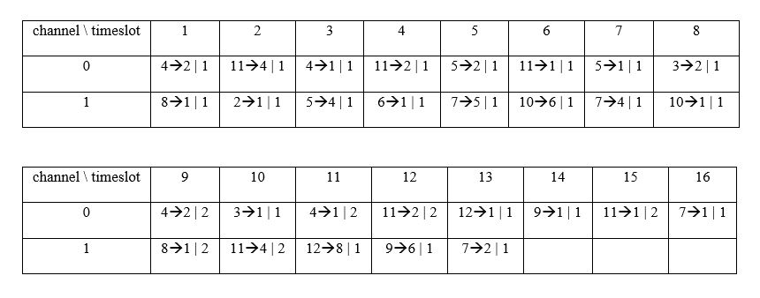
Fig. 3. Example output of PC-LLF scheduling for tree topology in Fig.1.
The PC-LLF algorithm makes the schedule for all transmissions with slot frame length is equal to the Least Common Multiplier of data period of all nodes in the network (LCM=16) (Fig.3). The transmission is noted as {SD | I} where S is the source node id of the packet, D is the destination node id and I is the instance of the packet which specifies the current period of the transmission, as all transmission is periodic. In the example (Fig.1) nodes $N_{4}, N_{8}$ and $N_{11}$, for example, have two packets to transmit within the LCM. The number of periods of transmission is defined by the LCM divided by the period value of the sender node’s transmission. At timeslot (ts=1, ch=0), the transmission from node 4 to node 2 was assigned. Then in the timeslot (ts=3, ch=0), the transmission from node 2 to node 1 was as-signed to forward the packet from node 4 to node 1.
  - Installing schedule
After making the schedule for the network, each node in the network has to install the schedule information to know which time it transmits, receives, and sleeps. To ensure the contention-free schedule to download the information packets from the coordinator to all the nodes, we continue to use autonomous dedicated timeslot assigned by Orchestra sender-based in the Initialization step.
Based on the tree topology and the schedule information created for each node. The coordinator creates a unicast packet for each link in the network. Firstly, it runs the Depth First Search (DFS) Algorithm [8] on the tree topology to find the path data for each link. After process all the path data, we continue process cell tuples. In the IEEE802.15.4e standard, timeslot and channel offset are encoded on 2 bytes for each one value. Since there are only 16 channels available, only 4 bits are needed to encode the channel offset. Furthermore, the slot frame length in an IEEE802.15.4e TSCH network is unusually greater than 1000 timeslots, channel offset can be encoded using 12 bits. A 1-byte data called “cell” can encode timeslot offset and channel offset, the 4 bits represent the channel offset and the remaining 12 bits for the timeslot offset. In the IEEE802.15.4 TSCH standard, the Maximum Transmission Unit (MTU) at the PHY layer is 127 bytes. MAC header and footer require up to 29 bytes in the context of the IEEE802.15.4e TSCH mode for 64 bit long MAC address. In our implementation, we use the short address 16 bit instead of 64 bit to extend the MAC payload from 98 bytes to 110 bytes.
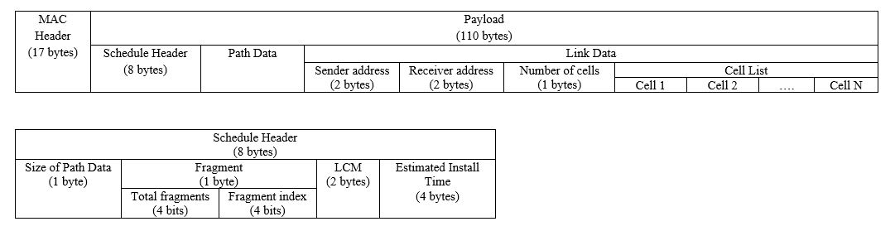
Fig. 4. Schedule an information packet format.
Fig. 4 shows the schedule information packet establishes by MAC Header and in the payload contains the schedule information packet: Schedule Header, Path Data, and Link Data. To determine the size of Path Data, we use one field called Size of Path Data in Schedule Header. Since the size of Path Data less than the maximum of tree depth, only 1 byte is used. For example in Fig.1, Path Data of link L(7, 5) is {1, 2, 4, 5, 7} has the size is 5. A large number of nodes in the network imply the fragmentation of the schedule information packet for each link, thus the Schedule Header contains the Fragment field to handle that. The Fragment has Total fragments and Fragment index to determine the total number of the schedule information packet has been divided, and the currently being transmitted packet. It has LCM which is the slot frame size of all transmissions in the network. The last field in Schedule Header is the Estimated Install Time denoted ${ASN}_{est}$. Considering that each node has its timeslot to send the packet, we considered the maximum duration to send the packet by unicast from Coordinator to all the nodes of the network to be equal to the total number of schedule packet denoted $N_{total packets}$plus the maximum depth $D_{max}$ of the tree topology then multiply with the number of the maximum retransmission we set in the MAC TSCH Layer $N_{\max{retrans}}$. All the results multiply with the slot frame length ${SF}_{length}$ to transmit the scheduled packet follows equation (3). Currently, we use Orchestra sender-based, the slot frame length is equal to the number of nodes.
$${ASN}_{est}= {ASN}_{current}+\left[\left(N_{total packets}+D_{\max{}}\right)*N_{\max{ retrans}}\right]*{SF}_{length}\left( SEQ "equation" \backslash n \backslash * MERGEFORMAT 3\right)$$
In the Link Data field, we use 4 bytes to save the sender and receiver address and 1 byte to save the number of cells in CellList. Considering the max tree depth is 16 means the Path Data is 16 bytes, we can calculate one schedule information packet can contain at most 81 scheduled cells (81 bytes). If all the cell assigned for each link has the number of cells lower than 81 cells, the total number of the schedule information packet for the tree topology using our method in Fig.1 is 11 packets.
After creating a schedule information packet for a link. This packet will be sent following the Path Data. The receiver node will check the Link Data information to do one of three processes. Each node has the cell list to transmit data packet (TxCellList) and cell list to receive data packet (RxCellList). If the receiver node id equal to the receiver id in the schedule information packet, the receiver node will save CellList to its RxCellList then update the Path Data and forward the schedule information to next-hop. If the receiver node id equal to the sender id in the schedule information packet, the receiver node will save CellList to its TxCellList then remove the schedule information packet due to Path Data is ended. If the node id is not equal to the sender and receiver id of the schedule information packet, the receiver node only updates the Path Data then forwards the schedule information to next-hop. For example in Fig.1, Path Data of link L(2, 1) is {1, 2}. The Coordinator node (Node 1), will save the CellList to its RxCellList, then update the Path Data to {2} and forward the schedule information packet to Node 2. Node 2. With the link L(7, 5) has Path Data is {1, 2, 4, 5, 7}, the schedule information packet will be forward from Node 1 to Node 2 to Node 4 then processed in Node 5 and Node 7. In each receiver, the Path Data will be updated consecutively from {1, 2, 4, 5, 7} to {7}.
  - Data Transmission
After the installing schedule process, each node knows from the RxCellList and TxCellList specifically at which cell it has to transmit or to receive the data packet. The data transmission period for data transmission is equal to the LCM value of all node’s periods in the network. During data transmission, when a node wakes up at its assigned cell, it checks first if the current cell is for reception mode then the node listens for the packet and after the reception, it adds the packet in its incoming queue. If the assigned cell for transmission mode, the node firstly checks if any packet is available in its outgoing queue buffer, get the packet from the queue, and send it; after transmission, the packet is removed from the queue. In case the queue buffer is empty, it switches into sleep mode. With the intermediate node, after adding the packet to the incoming queue, it checks itself is the Coordinator or not. If not, it will copy the packet to its outgoing queue to forward it to the next hop. All the data of the network will be transmitted towards the Coordinator.
- Evaluation
The PC-LLF algorithm was implemented using Contiki-NG OS real hardware of Zolertia RE-Mote B. One node acts as the Coordinator node.
We compared the number of packets messages used by our method and those used by standard-based CoAP, CoMI, and the custom-built OCARI to install the schedule information to the network.
Compare with CoAP and CoMI is a standard base approach to installing schedule only 32 bytes are available for the actual encoding of the schedule, as the remainder of the frame is occupied by the headers of the different standards. An alternative is OCARI, a custom-built non-standards based protocol, the maximum payload available for cell tuples in a beacon is 80 bytes, up to 11 cell tuples can be transported in a single beacon due to one cell use 7 bytes as described in [9].
Table 1. The total number of messages required for installing the schedules.
Node | Number of cells | Our method | CoAP  Single | CoAP  Patch | OCARI
2 | 15 | 1
3 | 1 | 2
4 | 10 | 2
5 | 3 | 3
6 | 5 | 1
7 | 1 | 4
8 | 4 | 1
9 | 1 | 2
10 | 1 | 2
11 | 2 | 3
12 | 1 | 2

- Conclusion
In this paper, a PC-LLF algorithm centralized schedule for real-time TSCH network was implemented using Contiki-NG OS, and RPL Lite used for the routing protocol. We integrated the PC-LLF library in the existing stack structures of Contiki-NG OS. To ensure the reception by all nodes of the schedules table information, we successfully used our installing method which shown better results than CoAP or OCARI. The result of implementation shows that our method to install the schedule table and the PC-LLF algorithm can run in the real environment which is helpful for industrial wireless sensor networks.

References
[1] K. Singh, H. Chaouchi, and J.-M. Bonnin, “Wireless sensor networks: A survey on recent developments and potential synergies,” J. Supercomput., vol. 68, 2013, doi: 10.1007/s11227-013-1021-9.
[2] R. Zurawski, “Networked Embedded Systems: An Overview,” 2017, p. 1.
[3] 802.15. 4e-2012, “IEEE standard for local and metropolitan area networks—part 15.4: low-rate wireless personal area networks (LR-WPANs) amendment 1: MAC sublayer.” IEEE Standard, 2012.
[4] A. Darbandi and M. K. Kim, “Path collision-aware real-time link scheduling for TSCH wireless networks,” KSII Trans. Internet Inf. Syst., vol. 13, no. 9, pp. 4429–4445, 2019, doi: 10.3837/tiis.2019.09.006.
[5] G. Mulligan, “The 6LoWPAN architecture,” in Proceedings of the 4th workshop on Embedded networked sensors, 2007, pp. 78–82.
[6] D. Dujovne, T. Watteyne, X. Vilajosana, and P. Thubert, “6TiSCH: deterministic IP-enabled industrial internet (of things),” IEEE Commun. Mag., vol. 52, no. 12, pp. 36–41, 2014.
[7] T. Winter, P. Thubert, A. Brandt, J. Hui, and R. Kelsey, “Routing protocol for low-power and lossy networks,” Tech. report, rfc 6550, 6551, 6552. IETF, 2012.
[8] Charles Pierre Trémaux, “Depth First Search algorithm.” [Online]. Available: https://en.wikipedia.org/wiki/Depth-first_search.
[9] E. Livolant, P. Minet, and T. Watteyne, “The Cost of Installing a 6TiSCH Schedule BT - Ad-hoc, Mobile, and Wireless Networks,” 2016, pp. 17–31.

